Story Board

Brittany McCarthy(24006620)
Faculty of Computing and Information Technology, University of Technology, Jamaica
Class:UE2 Friday 7pm-9pm
Assignment: IA2
CIT2011

Mission Statement

At Slay By Britts we envision a world where creativity, elegance, and personalized designs bring people together, making every event a true reflection of happiness and style. Our mission is to bring joy one decoration at a time by transforming our customers’ visions into reality. We are committed to delivering creative, personalized, and high-quality party décor that exceeds expectations. Our goal is to make every celebration unforgettable by being dedicated, hardworking, precise and attentive.

Vision statement

To be the leading party decoration company that transforms every celebration into a joyful and unforgettable experience. We aim to have stores island wide and aboard and to make our name a household one.

Logo
Our logo as our company colours pink and white. We use the colour pink to represent us as it conveys joy, creativity and it’s a very noticeable colour which is eye catching perfect for our party decoration brand. We also have B on our logo representing our founder’s first name initial Brittany. Its embedded in a decorative shield which give a sense of prestige and elegance. We also have our company’s name “SLAY BY” written in uppercase, bold letters to bring emphasizes to our name and it also signify strength and confidence. Below, we have “BRITTS” which appears in a smaller, refined font, creating balance. Overall, our logo is said to give of feminine energy which is a symbol as our brand is own by a female and also have a female dominated staff and most of our customers are also females.
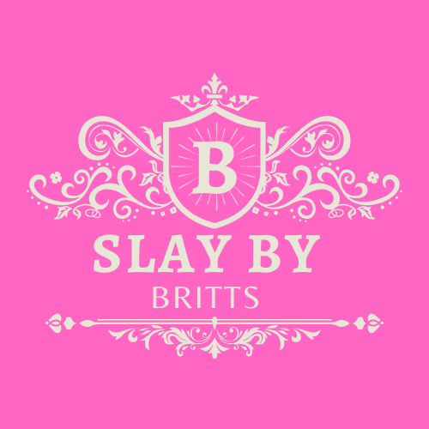

Our Audience

At Slay By Britts, our services are designed for the public. We cater to everyone young, middle-aged, and elderly. If you have an event that needs decorating, we’re here to make it extraordinary. No matter the occasion, we bring your vision to life with creativity and elegance.

Slogan
Our slogan is “Creating joy, one decoration at a time.”

Icons
On our website we use the save icon 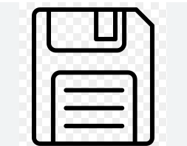
We also use the copyright icon in our footer 

Roots
Back ground colour for body across webpages variable #E8D5E7;
Font across all webpages for desktop 'Times New Roman', Times, serif; size 16
And for mobile its size 14.
Main text colour for webpages is black
Webpages layout
Logo left align at top of page
Heading centred in div with bold text with width of 50%
Navigation with home products and cart with padding of 8 pixcles and a margin of 30 pixels and text centred
Content centred of page
Footer at bottom of page

Colour palette
Down below is our colour palette consisting of different shades of purple, pink and blue.
Pink- As a party decoration company we are all about creativity and attention. We create and design eye catching decorations for our customers daily and we want our website to showcase this hence why we chose to use different shades of pink throughout our webpages to represent creativity and catching the eyes of our audience . This colour can be seen use in our headings and buttons, which emphasizes their importance while showcasing our vibrant personality. Additionally, we also chose this colour as it signifies femineity, joy, compassion and tenderness which are qualities our brand embodies
Blue- Blue brings balance to our palette. Widely used in business design, it conveys stability, trust, and control. We incorporate blue to tone down the intensity of pink, ensuring our site remains polished and professional. This strategic contrast helps us maintain visual harmony while reinforcing our credibility.
Purple- Purple represents the elegance and luxury that Slay by Britts delivers. Historically associated with royalty and affluence, purple adds a touch of elegance to our brand. We use it to reflect the classy and prestigious themes we create for our clients which are adored and remembered.

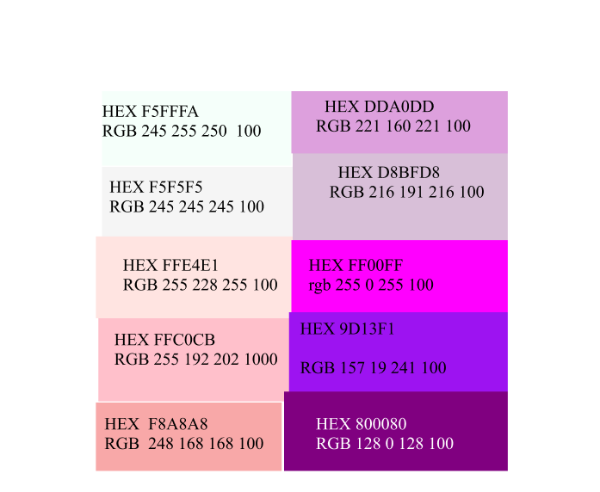

Mobile Design (600 px)

Login page
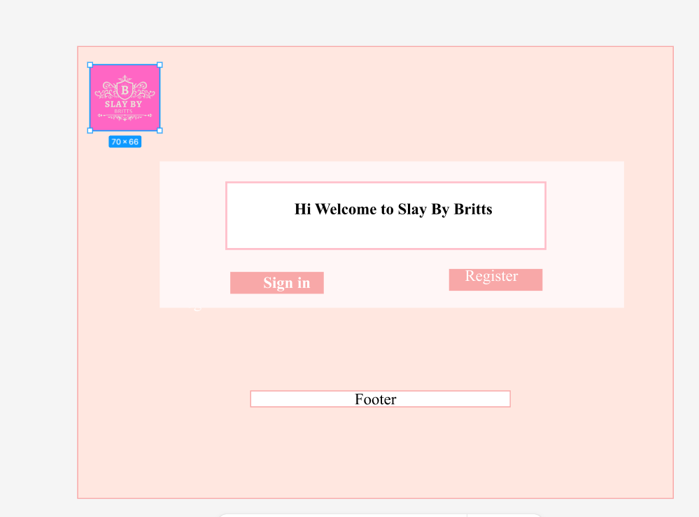

Sign in page
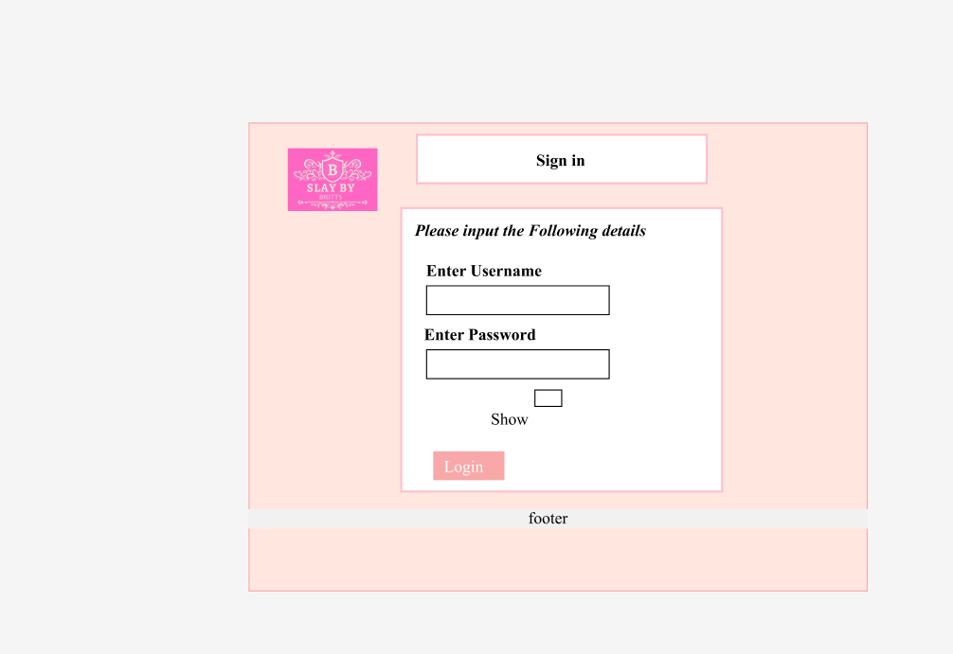

Register Page
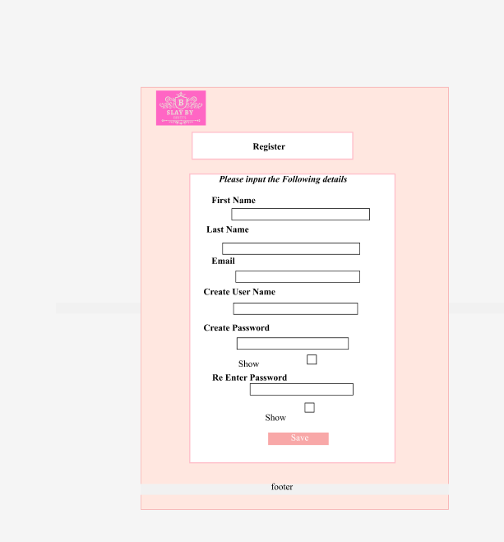

Home page
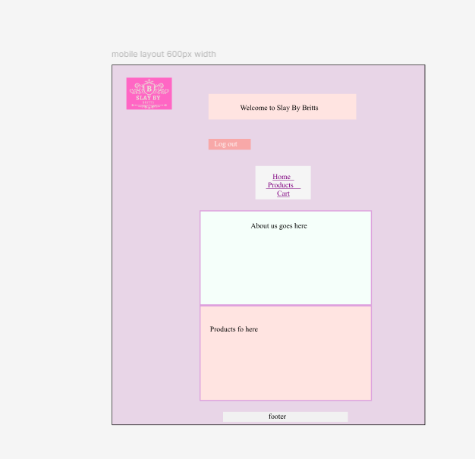

Birthday page
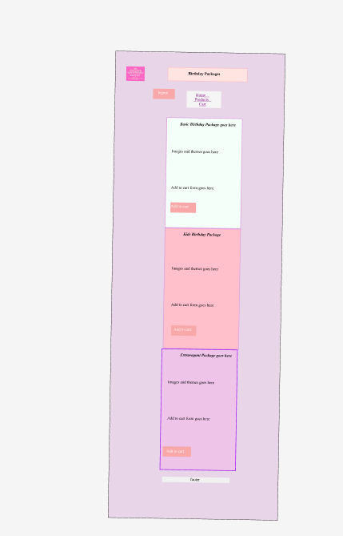

Marriage page

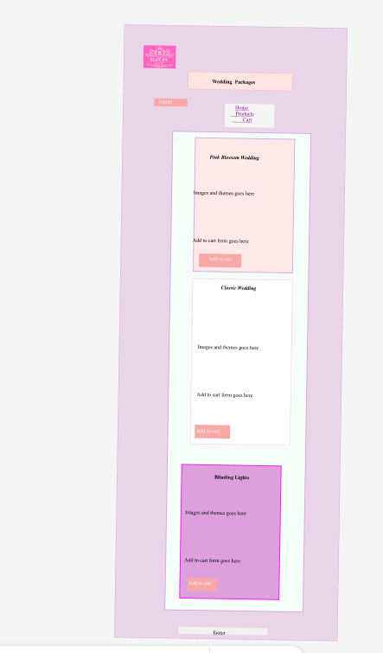

Baby shower page
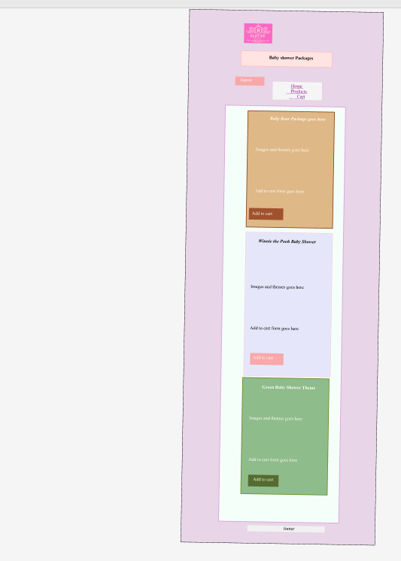

Custom page
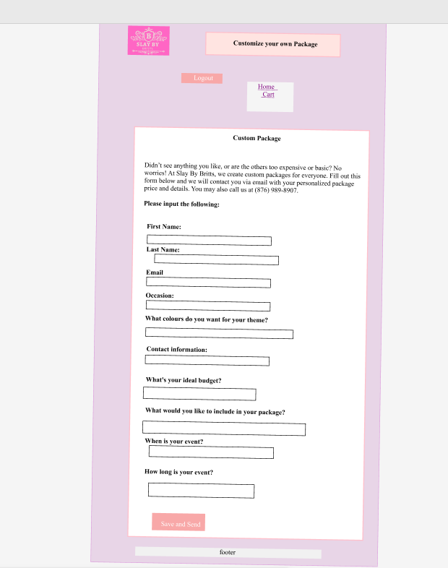

Cart page
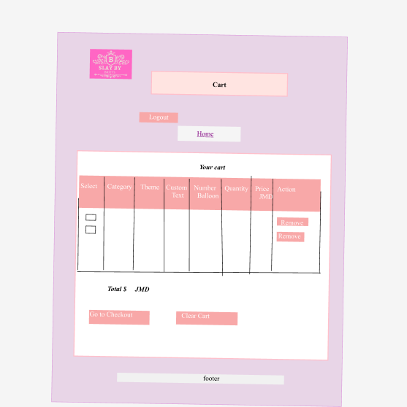

Checkout page
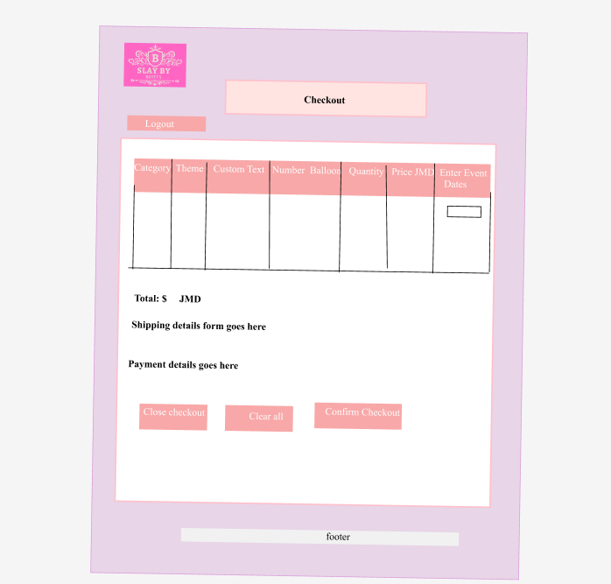

Desktop Design (950 px)

Login page
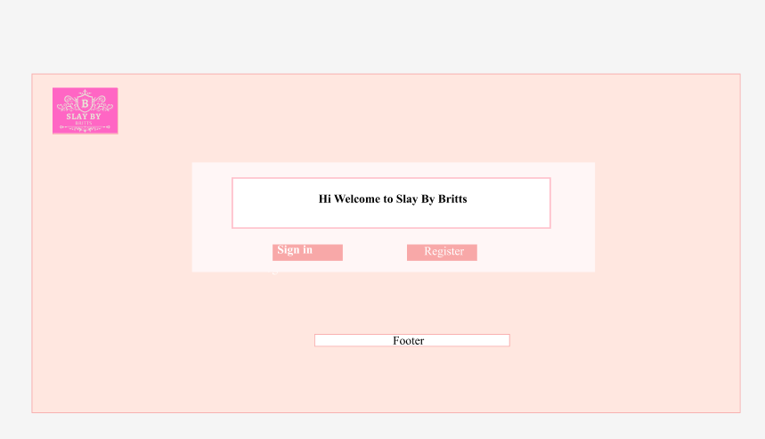

Sign in page
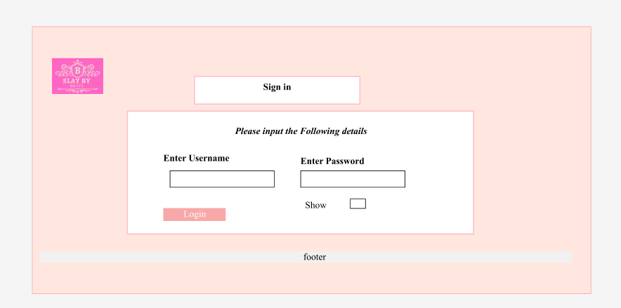

Register Page
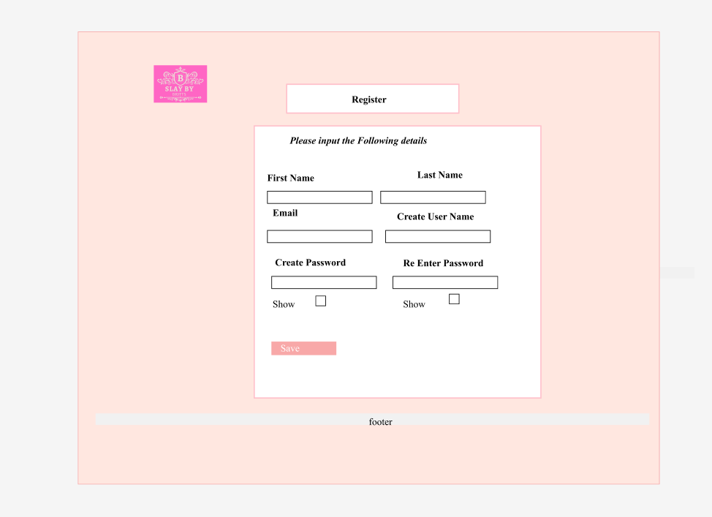

Home page
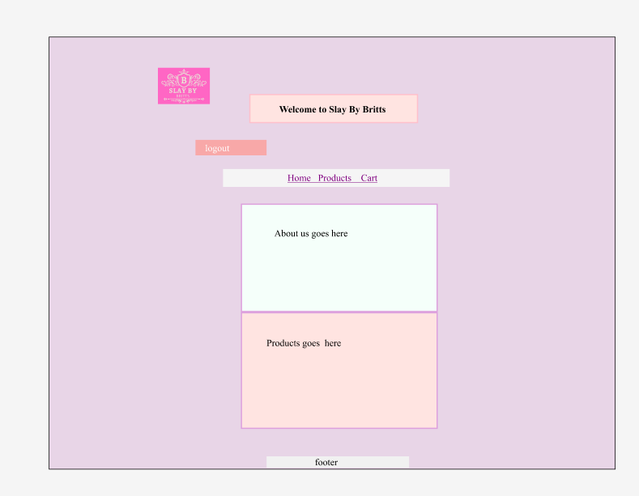

Birthday page
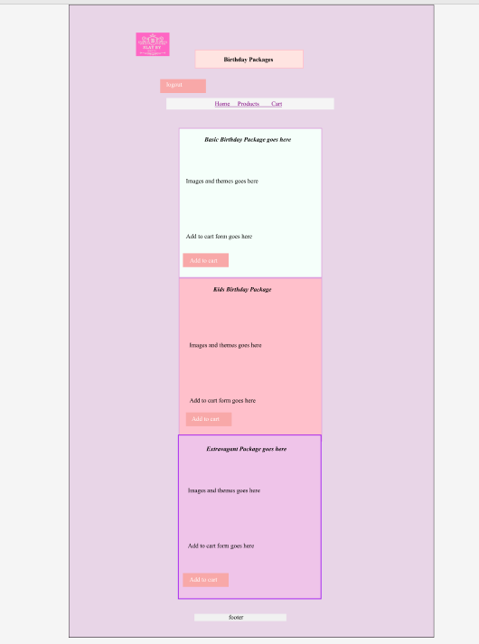

Marriage page
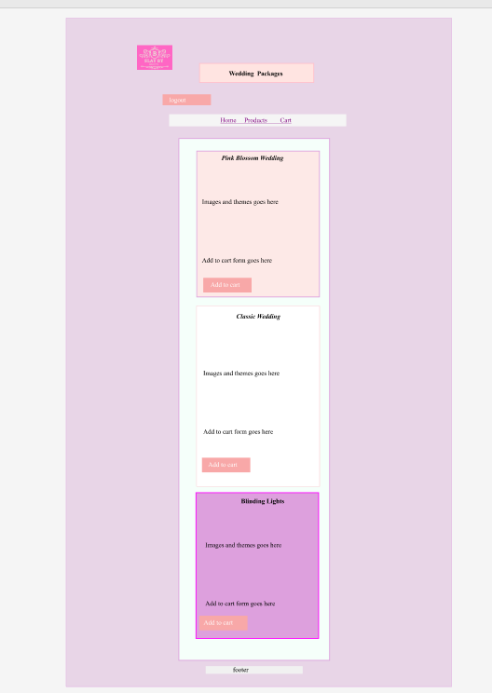

Baby shower page
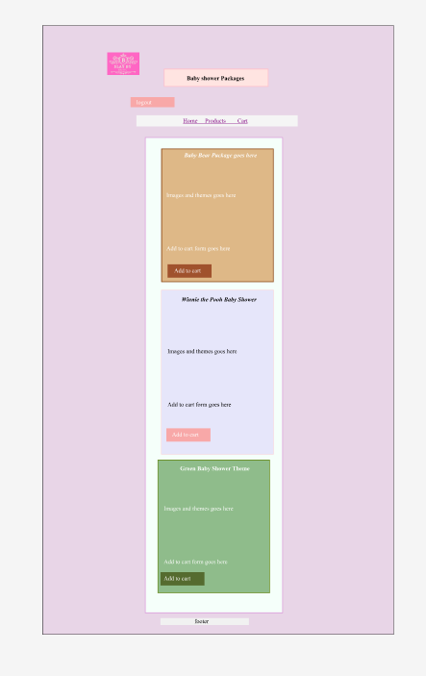

Custom page

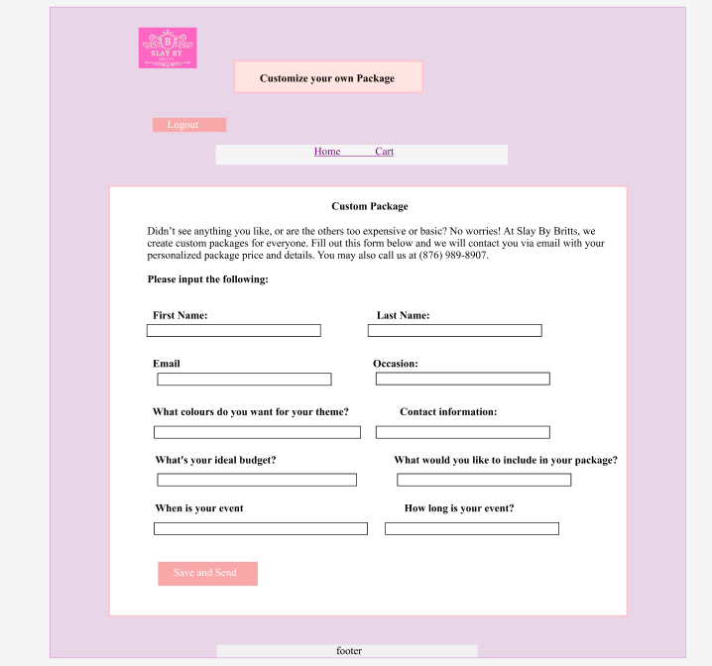

Cart page
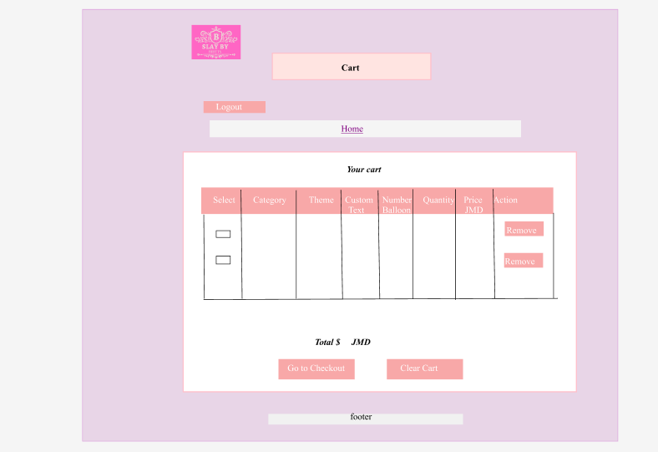

Checkout page
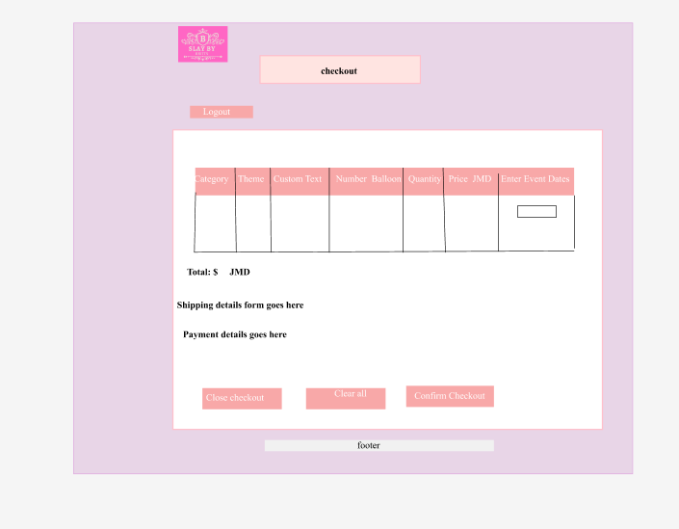

Reference list
Host link https://britts391.github.io/2400662brittanymccarthy-IA2.github.io/
Repository link https://github.com/britts391/2400662brittanymccarthy-IA2.github.io

Welcome wedding sign (n.d.) Pinterest
https://www.pinterest.com/pin/1136736762221847195/
Sage Green Balloon Garland Arch Kit (n.d.) Pinterest
https://www.pinterest.com/pin/AcBuZtCpRNecKNUA2bXn7AJOMI9eeLcqbZn5Gs45oHjurmClPEmVMYv20KxWs1JSngnswGqzwQB1C1PiZ2zXnMo/
Southern Boho Baby shower/ Western Baby shower (n.d.) Pinterest
https://www.pinterest.com/pin/1136736762221847143/
Pinterest (n.d.)
https://www.pinterest.com/pin/1136736762221877489/
Princess décor (n.d.) Pinterest
https://www.pinterest.com/pin/1136736762221877489/
Pinterest (n.d.)
https://www.pinterest.com/pin/1136736762221763468/

Pinterest (n.d.)
https://www.pinterest.com/pin/1136736762221718167/

Christmas Green Dragon Dinosaur Mascot (n.d.) Pinterest
https://www.pinterest.com/pin/1136736762221714654/
Bundle Unicorn Mascot Costume (n.d.) Pinterest
https://www.pinterest.com/pin/1068690186573464562/
Paw Patrol Mascots (n.d.) Pinterest
https://www.pinterest.com/pin/29132728833101187/
Dinosaur themed kids birthday backdrop (n.d.) Pinterest
https://www.pinterest.com/pin/1136736762221714467/

27+ Fun First Birthday Party Themes for Boys (n.d.) Pinterest
https://www.pinterest.com/pin/6192518232309654/
Pinterest (n.d.)
https://www.pinterest.com/pin/1136736762221847086/

20 Winnie the Pooh Baby Shower Ideas (n.d.) Pinterest
https://www.pinterest.com/pin/1136736762221847076/
Pinterest (n.d)
https://www.pinterest.com/pin/1136736762221847009/

Pinterest (n.d)
https://www.pinterest.com/pin/1136736762221714244/
Pinterest (n.d)
https://www.pinterest.com/pin/10836855345261270/

Paw Patrol theme Birthday Party Decorations (n.d.) Pinterest

https://www.pinterest.com/pin/20758848277033404/
Teddy Bear-Themed Baby Shower (n.d.) Pinterest
https://in.pinterest.com/pin/222998619043486169/
Baby Shower Ideas (n.d.) Pinterest
https://www.pinterest.com/pin/71705819061677227/
Pinterest (n.d)
https://www.pinterest.com/pin/425449496060301658/

Teddy Bear-Themed Baby Shower Inspirations Giant Teddy Bear Centerpiece Teddy Bears |Gift Ideas (n.d.) Pinterest
https://in.pinterest.com/pin/222998619043486169/

Throne chair rent (n.d) bloomnation
https://www.bloomnation.com/florist/unique-balloon-decorations/throne-chair-rent/
Pinterest (n.d)
https://www.pinterest.com/pin/703756186849044/

Classy Birthday Décor Using Backdrop Stand, Backdrop Cover, Balloons, Neon (n.d.) Pinterest
https://in.pinterest.com/pin/299207969016468165/
Backdrop Birthday Black and gold Chic Style (n.d.) Balloons over ottawa
https://balloonsoverottawa.ca/products/backdrop-baby-shower-birthday-boho-chic-style-copy
Black Table Cloth 130 Diameter (n.d) BE Furniture
https://www.beeventhire.co.uk/product/black-table-cloth-130-diameter/

AULE 40 Inch Big Black 8 Balloon Number Large Foil Helium Number Balloons 0-9 Jumbo Giant Happy 8th Birthday Party Decorations for Boy or Girl Huge Mylar Anniversary Party Supplies
https://www.amazon.ca/AULE-Balloons-Birthday-Decorations-Anniversary/dp/B0C1NRMHRN?th=1

Pinterest (n.d)
https://www.pinterest.com/pin/418834834119517036/
Pinterest (n.d)
https://se.pinterest.com/pin/384565255699472848/
Pinterest (n.d)
https://in.pinterest.com/pin/825918019202400874/
Diamond Jewelry | Montreal Diamond Jeweler | (n.d.) Pinterest
https://www.pinterest.com/pin/354025220717996946/
Pinterest (n.d)
https://www.pinterest.com/pin/1136736762221847270/

141 Pcs Burgundy and Rose Gold Balloon Garland Arch Kit (n.d) Pinterest
https://es.pinterest.com/pin/234046511880314611/
Pinterest (n.d.)
https://www.pinterest.com/pin/1087197166296625216/
Elegant All-White Wedding with Glowing Lanterns (n.d) Pinterest
https://se.pinterest.com/pin/844493675888260/
Pinterest (n.d.)
https://mx.pinterest.com/pin/633387442264623/

40 Inch Red Large Number (n.d.) Pinterest
https://it.pinterest.com/pin/909375349742293260/

20 Unique Wedding Welcome Sign Ideas (n.d.) Pinterest
https://it.pinterest.com/pin/1136736762221847201/
Pinterest (n.d.)
https://www.pinterest.com/pin/724798133816282516/
Pinterest (n.d.)
https://in.pinterest.com/pin/628181848063775224/
Pinterest (n.d.)
https://www.pinterest.com/pin/798263102746226058/
Pinterest (n.d.)
https://in.pinterest.com/pin/914862420979095/
Pink café (n.d) Pinterest
https://www.pinterest.com/pin/612700724342419193/

40 Inch Giant Hot Pink Number Balloon, Mylar Foil Helium Hot Pink Balloons for Birthday
Party, Number 1 Balloon for Birthday Decorations, Hot Pink 1 Birthday Balloon (n.d) Amazon
https://www.amazon.com.au/Number-Balloon-Balloons-Birthday-Decorations/dp/B0CKQLFR2V?th=1
Pinterest (n.d.)
https://www.pinterest.com/pin/22729173115461037/
Pinterest (n.d.)
https://www.pinterest.com/pin/1266706140943215/

2 Packs Pink Polyester Table Clothes for 6 Foot Rectangle Tables, Wrinkle Free Fitted Table Cover 6ft Stretch Tablecloths with Skirt for Parties Weddings Birthday Banquet Baby Shower (n.d) Amazon
https://www.amazon.com/Polyester-Rectangle-Tablecloths-Weddings-Birthday/dp/B0CRT8G554?th=1
Bomacy Royal Pink Queen Pedicure Throne Chair Foot SPA With Bowl for Beauty Salon Furniture (n.d.) Alibaba.com
https://www.alibaba.com/product-detail/Bomacy-Royal-Pink-Queen-Pedicure-Throne_60549389528.html

Pinterest (n.d.)
https://it.pinterest.com/pin/1136736762221847241/
Pinterest (n.d.)
https://it.pinterest.com/pin/1136736762221847245/
Pinterest (n.d.)
https://www.pinterest.com/pin/1083819466586572759/
Future wedding plans (n.d.) Pinterest
https://in.pinterest.com/pin/775182154651348054/
Pinterest (n.d.)
https://it.pinterest.com/pin/772156298652437206/
M Disney princesses (n.d.) Basil’s Bouncy Castle
https://www.bbcastles.com/category/m-manned-mascot-visits/668/m-disney-princesses
Pinterest (n.d.)
https://www.pinterest.com/pin/145030050496140116/
Pinterest (n.d.)
https://mx.pinterest.com/pin/81135230775271086/

Instagram icon (n.d.) Raw pixel
https://www.rawpixel.com/search/instagram%20icon?page=1&path=1522&sort=curated

108pcs, Pink Purple Balloon Garland Arch Kit (n.d.) Pinterest
https://www.pinterest.com/pin/610871136991794477/
Pinterest (n.d.)
https://in.pinterest.com/pin/12736811442668178/
Pinterest (n.d.)
https://es.pinterest.com/pin/806777720777909820/
Tiktok logo (n.d) Vecteezy
https://www.vecteezy.com/png/31737228-tiktok-logo-tiktok-app-social-media-icons
Pinterest (n.d.)
https://ca.pinterest.com/pin/768708230175078975/

Colorful Rainbow Balloon Garland Arch Kit Pastel Macaron Balloons Wedding Unicorn Birthday Party (n.d) Pinterest
https://www.pinterest.com/pin/694961786284483884/

Wedding ideas (n.d) Pinterest
https://www.pinterest.com/pin/1136736762221847232/

Pinterest (n.d)
https://in.pinterest.com/pin/93027548550398360/
Pinterest (n.d)
https://mx.pinterest.com/pin/651614639852858607/
Pinterest (n.d)
https://www.pinterest.com/pin/614178467973185748/
Pinterest (n.d)
https://www.pinterest.com/pin/657877458103188945/
Pinterest (n.d)
https://www.pinterest.com/pin/715650197078429909/

Fairytale Princess Castle Decorations for magical birthday theme (n.d.) Pinterest
https://www.pinterest.com/pin/155303888164228260/
HTML UTF-8 Characters (n.d) W3 schools
https://www.w3schools.com/charsets/ref_emoji_body.asp
Color Palettes forDesigners and Artist (n.d) Colour Hunt
https://colorhunt.co/palette/ffecc0ffc29bf39f9fb95e82
HTML tutorial (n.d) W3 schools
https://www.w3schools.com/html/default.asp
CSS tutorial (n.d) W3 schools
https://www.w3schools.com/css/default.asp
Java Tutorial (n.d.) W3 schools
https://www.w3schools.com/js/default.asp

